EXPERIMENT 4
Name: Harshavarthini A Roll No: 240701181
Create a prototype with familiar and unfamiliar navigation elements. Evaluate ease of use with different user groups using proto.io
Screen 1:
Sign In page for the Sweet Cravings app:
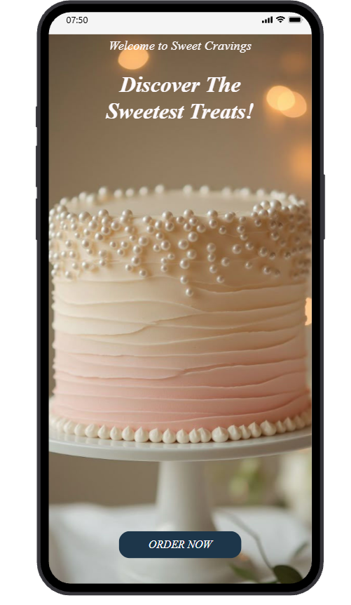

Familiar Icons:
Status Bar Icons (Top Right Corner):
o Signal Strength Bars: Shows the strength of the cellular network signal.
o Wi-Fi Icon: Shows the device is connected to a wireless network.
o Battery Percentage: Shows the percentage of battery life remaining for the device.
o Time (07:24): Shows the time.
Possibly Unfamiliar Icons:
"ORDER NOW" Button:
o The purpose of the button is obvious, and it is a call to action.
o For a dessert-related application, it might be more common for users to see buttons such as "Add to Cart," "Buy Now," or "Customize Your Order." While the button is functional, the wording is quite generic and might not reflect standard wording for ordering food items.
Screen 2:
Cake List Screen:
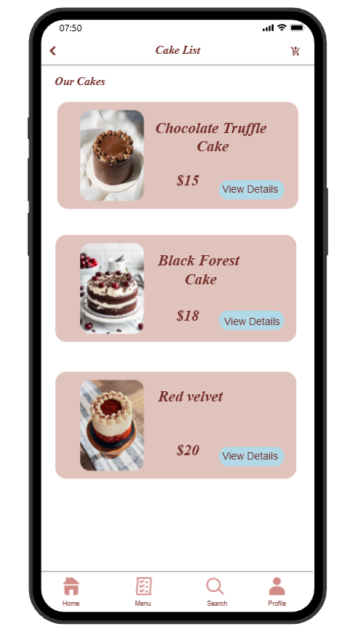
For the Second Image (Cake List Screen):
Familiar Icons:
- Status Bar Icons: Signal strength, Wi-Fi, battery level, and time (07:50) are common mobile phone icons.
- Back Arrow: This arrow is used for navigation to the previous screen.
- Cart Icon: This icon represents the shopping cart, which contains the items selected by the user.
- Bottom Navigation Icons:
- Home: This icon opens the main screen.
- Menu: This icon displays the cake list.
- Search: This icon assists the user in searching for specific items.
- Profile: This icon displays the user profile information.
- Cake Cards: These icons display the cake image, cake name, cake price, and the button for more information.
Possibly Unfamiliar Icons:
- “View Details” Button: The user might expect the button to read “Add to Cart” or “Order Now.”
- Card Background Design: The user might assume the entire cake card is clickable, rather than the button.
Screen 3:
Cake Description Screen:

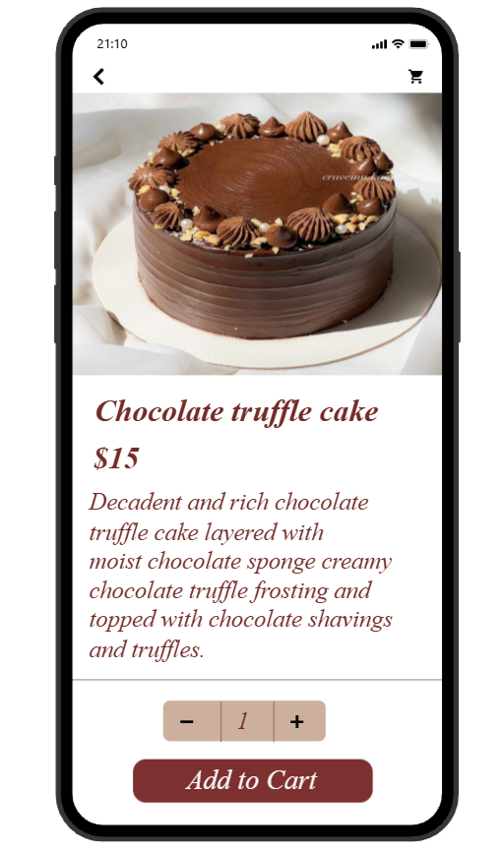
Familiar Icons:
- Status Bar Icons: Signal strength, Wi-Fi, battery level, and time (21:10) are common icons used in mobile devices.
- Back Arrow: This is used to go back to the previous screen.
- Cart Icon: This allows the user to view the selected items in the cart.
- Product Image: This is shown to help the user visually identify the product.
- Price Display ($15): This is shown to help the user see the price of the product.
- Quantity Selector (-/+): This allows the user to add or subtract the quantity of the product.
- “Add to Cart” Button: This is a common function used in online shopping to add the product to the cart.
Possibly Unfamiliar Icons:
- Long Description Text: Users may want to have shorter descriptions in the form of bullet points instead of a long paragraph of text.
- Quantity Selector Design: Users may expect a dropdown or input box to select the quantity instead of the -/+ buttons.
Screen 4:
My Cart Screen:
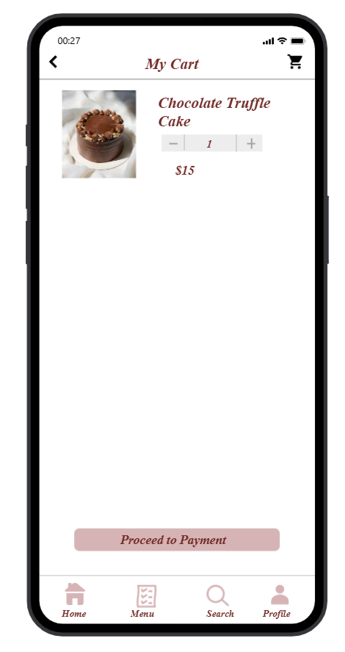
Familiar Icons:
- Status Bar Icons: Signal strength, Wi-Fi, battery level, and time (00:27) are standard icons for a device’s status bar.
- Back Arrow: This is used for navigation purposes, i.e., going back to the previous screen.
- Cart Icon: This icon is used for the shopping cart section of the application.
- Product Image: This icon helps the user identify the product, i.e., the cake they want to purchase.
- Cake Name and Price ($15): This icon displays the product details to the user.
- Quantity Selector (- / +): This icon helps the user increase or decrease the number of products they want to purchase.
- “Proceed to Payment” Button: This is a standard button for proceeding with the payment process for the product.
- Bottom Navigation Icons:
- Home: This icon is used to display the main screen of the application.
- Menu: This icon displays the list of cakes available for purchase.
- Search: This icon helps the user search for the product they want to purchase.
- Profile: This icon helps the user access their account.
Possibly Unfamiliar Icons:
- Single Item Cart Layout: Users might expect a summary of the total price or other items in the cart, as is standard for shopping applications.
Screen 5:
Payment Screen:
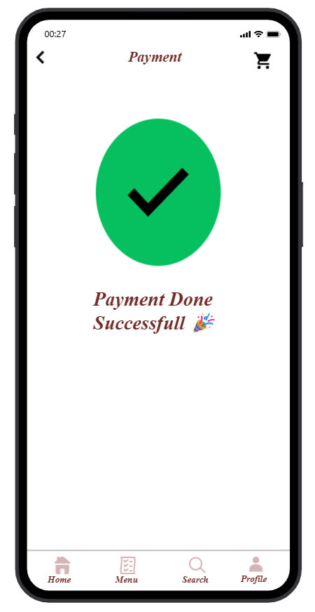
Familiar Icons:
- Status Bar Icons: Signal strength, Wi-Fi, battery level, and time (00:27) are common in most mobile devices.
- Back Arrow: Helps the user navigate back to the previous screen.
- Cart Icon: Represents the shopping cart icon.
- Checkmark Symbol: A common icon used to represent the completion of a task.
- “Payment Done Successful” Message: Confirms the completion of the payment process.
- Bottom Navigation Icons:
- Home: Opens the main screen.
- Menu: Displays the list of cakes.
- Search: Helps the user search.
- Profile: Opens the user profile.
Possibly Unfamiliar Icons:
- Large Green Circle with Checkmark: While it is used to represent the completion of a task, it is also used to show the order details or receipt after the payment process.
- No “View Order” or “Track Order” Option: Users may also want to view the order details or track the order after the payment process. 🎉

